**Mountain Lion Survey Protocol Using Trail Cameras in Yosemite National Park**

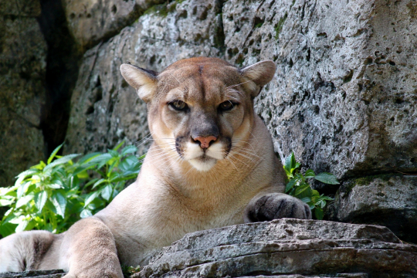

Sean M. Matthews1, David S. Green1, Breezy Jackson2, Mike McDonald2, and Sarah Stock2

1Institute for Natural Resources, Oregon State University

2Yosemite National Park

09 August 2019

# Introduction

Mountain lions (*Puma concolor*, also known as pumas, cougars, and panthers) are an apex predator that play an outsized role in the ecology of the Sierra Nevada. Mountain lions are an umbrella species for the conservation of a diverse array of co-occurring species throughout their range (Beier 1993, Logan and Sweanor 2001). As a wide-ranging species, they are also an indicator for habitat connectivity (Penrod 2000). Mountain lions also provide top-down regulation of prey populations (i.e., deer). Specifically, they limit deer from overgrazing native vegetation by limiting population sizes and by changing behaviors (Ripple and Beschta 2008). In fact, there is some evidence that mountain lions are instrumental in keeping deer from suppressing oak recruitment in Yosemite Valley (Ripple and Beschta 2008). Mountain lions also control movement patterns of competitors like coyote (*Canis latrans*) and bear (*Ursus americanus*) (Murphy et al. 1998).

Mountain lions might also influence conservation actions underway for co-occurring species of conservation concern. Sierra Nevada red fox (*Vulpes vulpes necator*), fisher (*Pekania pennanti*), and bighorn sheep (*Ovis canadensis sierrae*) live at extremely low densities within Yosemite, are in initial stages of reintroduction planning, or are actively being reintroduced to the park to restore the ecological communities of the Yosemite Wilderness. For each of these three species, mountain lions are a source of mortality via predation, which could hamper or prevent the success of these restoration efforts (Ernest et al. 2002).

Yosemite National Park may provide an important intact wilderness ecosystem to support mountain lion populations and genetic connectivity within California. Unfortunately, we lack an understanding of the current distribution and ecology of lions in Yosemite (see Ernest et al. 2000), and we lack critical baseline information about how important Yosemite is to their persistence. Our goal is to estimate mountain lion abundance and habitat associations using detection data collected using remote cameras and dog teams. This field protocol, in conjunction with the Scat-Detection Dog Survey Protocol for Yosemite National Park, is intended to 1) orient staff to the project and our goals and 2) provide step-by-step instructions for carrying out project tasks. Nevertheless, a written protocol is a living document and improves with experience and collaborative discussion. We look forward to working and learning together!

# Objectives

Our goal is to estimate the abundance and habitat associations of mountain lions and Sierra Nevada red fox in Yosemite National Park using non-invasive methods. We will use detection-dog teams to survey for carnivore scat and remote cameras to determine species occupancy. Scat collected will be genetically analyzed to species and those identified to be mountain lion or Sierra Nevada red fox will then be identified to individual by the Mammalian Ecology and Conservation Unit at the University of California Davis. Collaborators at the Institute for Natural Resources at Oregon State University will use the genetic identifications, photographic-detection data and, a combination of spatial capture-recapture and occupancy analyses to estimate population size and habitation association of mountain lions and Sierra Nevada red fox in Yosemite National Park.

# Methods

## Survey Sites

Our sampling design is based on a grid system of 10.4 km2 (4 mi2) hexagonal cells developed for multispecies monitoring by the California Department of Fish and Wildlife (Figures 1 and 2). A subset of these hexagons will be surveyed by detection-dog teams for carnivore scat (see Detection-Dog Survey Protocol for Yosemite National Park). Each survey year (2019 and 2020) we will deploy two unbaited, remotely-triggered cameras (Hyperfire Reconyx) in 21 randomly-selected hexagons that will not be surveyed by dogs in the same survey year. Lure (Gusto, Minnesota Trapline Products, Pennock, Minnesota, USA) will be used at each camera station to entice lions to linger for a longer period of time.

Within each of the 21 hexagons we will place 2 cameras at least 1 km apart along a canyon rim, ridge, saddle, drainage, or other terrain features that could be likely travel routes for mountain lions. Fine-scale site selection will involve placing cameras along wildlife trails or locations of mountain lion sign (e.g., tracks, scats, scrapes). An additional 20 cameras will be placed in locations of previous detections of Sierra Nevada red fox and areas of predicted high-quality red fox habitat (Figure 3).

## Background

This protocol is adapted from The Sierra Nevada red fox in Yosemite National Park: 2016-2017 survey protocol (Eyes et al. 2016), Guidelines for Sierra Nevada red fox surveys and monitoring (Sacks and Quinn et al. 2018), Klamath-Siskiyou Carnivore Project camera protocol (Matthews and Green 2018), and personal communications with Dr. Justin Dellinger with the California Department of Fish and Wildlife, Dr. Toni Ruth with the Salmon Valley Stewardship, and Dr. David Ausband with the Idaho Cooperative Fish and Wildlife Unit at the University of Idaho. Further details can be found in Eyes et al. (2016) on using a Garmin GPS (Appendix 5), using the Irfan View application (Appendix 6), safety (Appendix 8), and personal gear and overnight trips (Appendix 9).

## Supplies for Camera Setup and Checks

* Handheld radio with extra batteries
* GPS with extra AA batteries
* Compass
* Park map
* Map of CDFW hexagon grid cells and camera locations
* Handheld digital camera with memory card
* Reconyx trail cameras
* Memory cards for trail cameras
* Extra AA lithium batteries for trail cameras
* Bungee cords and cable lock for trail cameras
* Gusto lure
* Multi-tool (e.g., Leatherman)
* Phone with Survey123 for data collection (Appendix 2)

## Camera Setup

* Format SD photo card for camera on a computer:
  + Insert SD memory card into computer’s card reader.
  + Click “*Start > My Computer*.” You should see your memory card under the list of available drives. Be sure to check its contents first to confirm that the correct drive is selected.
  + Right-click on the drive and select “*Format*.”
  + Under “*File System*” select “*FAT32*” then click “*Start*.”
  + Once the process is complete, safely eject your memory card from computer’s card reader and insert it into your camera.
* Load 12 lithium AA batteries into the camera.
* Camera setup: It’s very important to select the correct battery type, otherwise we will get an inaccurate battery level reading. See Appendix 1 for Reconyx setup directions.

## Camera Deployment

* Navigate to the proposed location for the camera using a handheld GPS unit
* Starting from the proposed location, select a wildlife trail or linear feature likely to be used by mountain lions (Figure 4). Mountain lions usually take the “path of least resistance,” so trails used by wildlife or people are generally used by mountain lions. Cameras, however, will not be placed on NPS trails depicted on park maps as per the Minimum Requirement Analysis titled, “Determining the Current Distribution and Abundance of Mountain Lion in Yosemite National Park” executed on 2 July 2019.
* No 2 cameras should be less than 1km apart. This includes cameras in the same hexagon or cameras in neighboring hexagons. Greater distances between cameras is better.
* Select a tree, rock, or other structure, immediately adjacent to the wildlife trail or habitat feature. Ideally this feature is close to the trail along a straight stretch of the trail such that the sensor is projected as far along the trail as possible. The camera should be angled at ~45° to parallel (0°) with the trail (where 90° is perpendicular to the trail), and placed ~ 1m above the ground to best capture images of an animal traveling quickly.
* The camera should face a northerly direction (approximately 320˚ to 40˚) to avoid the sun resulting in poor image exposure, glare, and false triggers.
* Check to make sure that the photo center is ~2.5 m from the camera and parallel to the trail. The camera sensor should be parallel to the ground, adjust to accommodate slope.
* Attach cameras to tree with bungee cords. In high-use areas, use a steel cable lock (coated with flexible black plastic) to secure the camera to the tree.
* Make sure all cameras have labels that explain their use for wildlife monitoring.
* Use a hand held digital camera to take “reference photos” of the camera station
* The first picture should clearly show the Camera ID from the camera itself. Other photos should include:
  + A photo of the camera and its tree
  + A couple photos off to the side to show the general area, habitat type, notable features, etc.
* Record field data using Survey123 (Appendix 2)
* Enter passcode 1436 after turning the camera on. Double check camera settings (Appendix 1). Press OK to arm the camera before placing it in the mount.
* Walk in front of the camera to trigger it so a few pictures are taken along the mountain lion’s anticipated travel pathway. Use a handheld digital camera to verify that everything is centered, and make any necessary corrections to ensure the camera is targeted on the trail. If everything is centered well, turn the camera back on and wait for the camera to be armed. Be sure to leave the site so that the camera is triggered and gets a picture of your departure. This step may seem trivial but is extremely important for data collection.
* Distribute lure (Gusto) at site in a couple of locations along the travel path and, if possible, on the travel path to encourage animals to stop and investigate in view of the camera. Do not apply lure in areas where others checking the camera might step or brush against the lure.

## Camera Checks

Cameras should be revisited as frequently as logistics allow, ideally every 3-4 weeks. During each station revisit, the primary tasks are to:

* Inspect the camera and adjust/maintain as necessary
* Reposition camera to maintain protocol ground level distance due to changing snow conditions
* Enter a form in Survey123 for the current check and take a test photo (Appendix 2)
* Collect the camera’s memory card and replace it with a blank card
* Replace batteries as needed
* Take a second test photo

## Final Camera Check

At the end of the survey period (approximately 90 days), leave no trace practices will be applied to the camera stations and everything should be removed including any temporary flagging. The survey period for cameras placed to target mountain lions will conclude at the end of detection dog surveying in November 2019. The survey period for cameras placed to target Sierra Nevada red fox will conclude when conditions allow for camera retrieval in the spring and summer of 2020.

## Opportunistic Scat Collection

Field staff will also collect mountain lion, red fox, and fisher scats opportunistically while deploying and checking cameras. All scat should be collected and preserved using the same methods indicated in the Detection Dog Survey Protocol. Field staff should also collect GPS tracks of their movements to and from the camera to account for their effort. Upload tracks from each day setting and checking cameras as a GPX file to this folder U:\EP Resources\00. Wildlife Branch\00.Mammals\Mountain Lion\GIS - Mountain Lion Spatial Data\2019_Tracks

Label each days tracks with the date and your initials. Ex:  20190708_CRK (YearDayMonth_Initials)

## Tagging Photographs

The tagging of photographs will be completed using the same methods used for cameras placed to detect Sierra Nevada red fox. Details can be found in the Colorado Park and Wildlife photo warehouse user guide (Colorado Parks and Wildlife 2015).

# Literature Cited

Beier, P. 1993. Determining minimum habitat areas and habitat corridors for cougars. Conservation Biology **7**:94-108.

Colorado Parks and Wildlife. 2015. Colorado Park and Wildlife photo warehouse user guide. Fort Collins, CO.

Ernest, H.B., M.C.T. Penedo, B.P. May, M. Syvanen, and W.M. Boyce. 2000. Molecular tracking of mountain lions in the Yosemite Valley region in California: Genetic analysis using microsatellites and faecal DNA. Molecular Ecology 9:433-441.

Eyes, S., S. Stock, and B. Jackson. 2016. The Sierra Nevada red fox in Yosemite National Park: 2016-2017 survey protocol. National Park Service, Yosemite National Park. El Portal, CA.

Logan K.A. and L.L. Sweanor. 2001. Desert puma: evolutionary ecology and conservation of an enduring carnivore. Island Press, Washington, DC.

Matthews, S.M. and D.S. Green. 2018. Klamath-Siskiyou Carnivore Project camera protocol. Oregon State University, Institute for Natural Resources. Portland, OR.

Murphy K.M., G.S. Felzien, and M.G. Hornocker. 1998. Encounter competition between bears and cougars: some ecological implication. Ursus *10:55-60.*

Penrod, K. 2000. Missing linkages: Restoring connectivity to the California landscape. Proceedings of the Conference of November 2, 2000. San Diego Zoo, CA.

Ripple W.J. and R.L. Beschta. 2008. Trophic cascades involving cougar, mule deer, and black oaks in Yosemite National Park. Biological Conservation 141: 1249–1256.

Sacks B.N. and C.B. Quinn. 2018. Guidelines for Sierra Nevada red fox surveys and monitoring. University of California. Davis, CA.

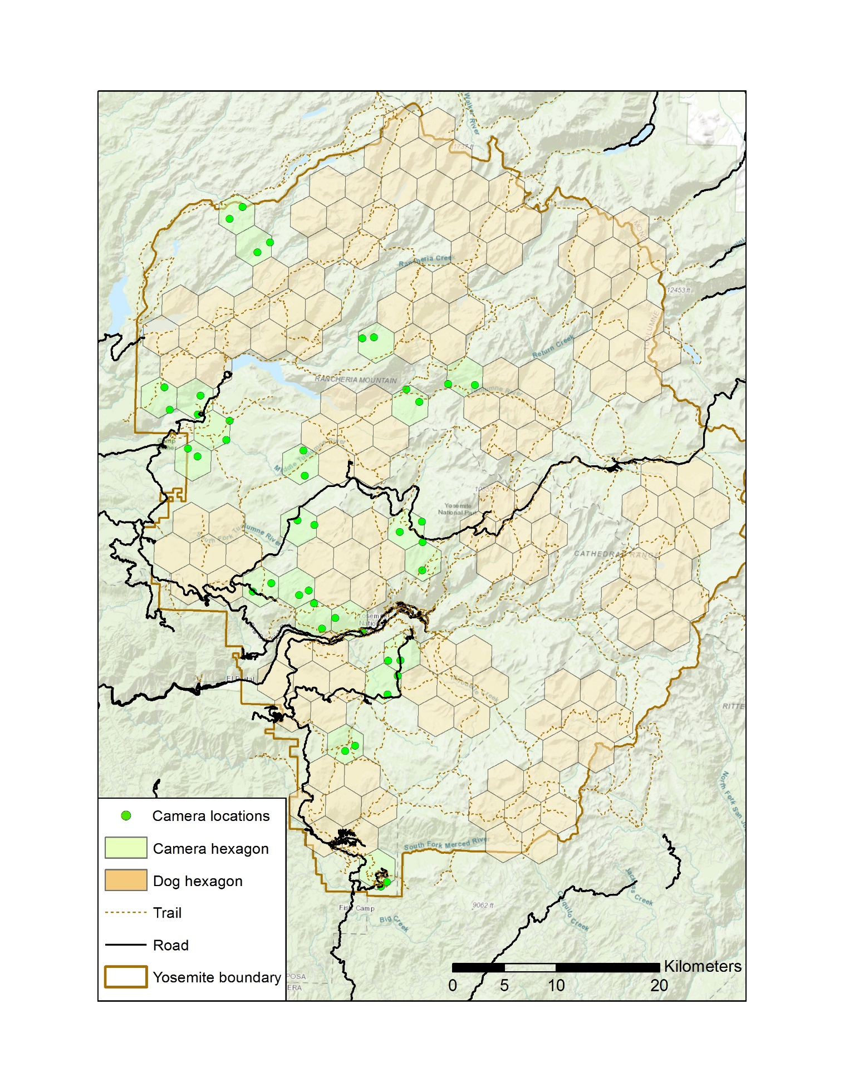

Figure 1. Survey plan for 2019 - A subset of 10.4 km2 (4 mi2) hexagonal cells developed for multispecies mesocarnivore monitoring by the California Department of Fish and Wildlife. Selected hexagons will be used to survey for carnivore scat using detection-dog teams (brown hexagons) and carnivore occupancy using unbaited, remotely-triggered cameras (green hexagons) in Yosemite National Park in 2019.

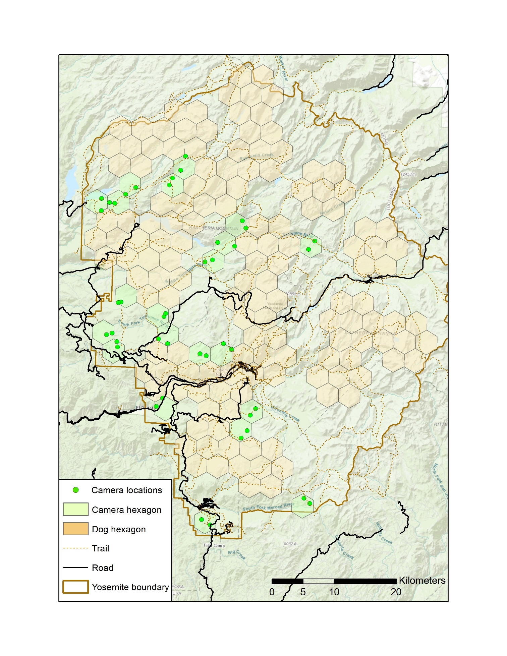

Figure 2. Survey plan for 2020 - A subset of 10.4 km2 (4 mi2) hexagonal cells developed for multispecies mesocarnivore monitoring by the California Department of Fish and Wildlife. Selected hexagons will be used to survey for carnivore scat using detection-dog teams (brown hexagons) and carnivore occupancy using unbaited, remotely-triggered cameras (green hexagons) in Yosemite National Park in 2020.

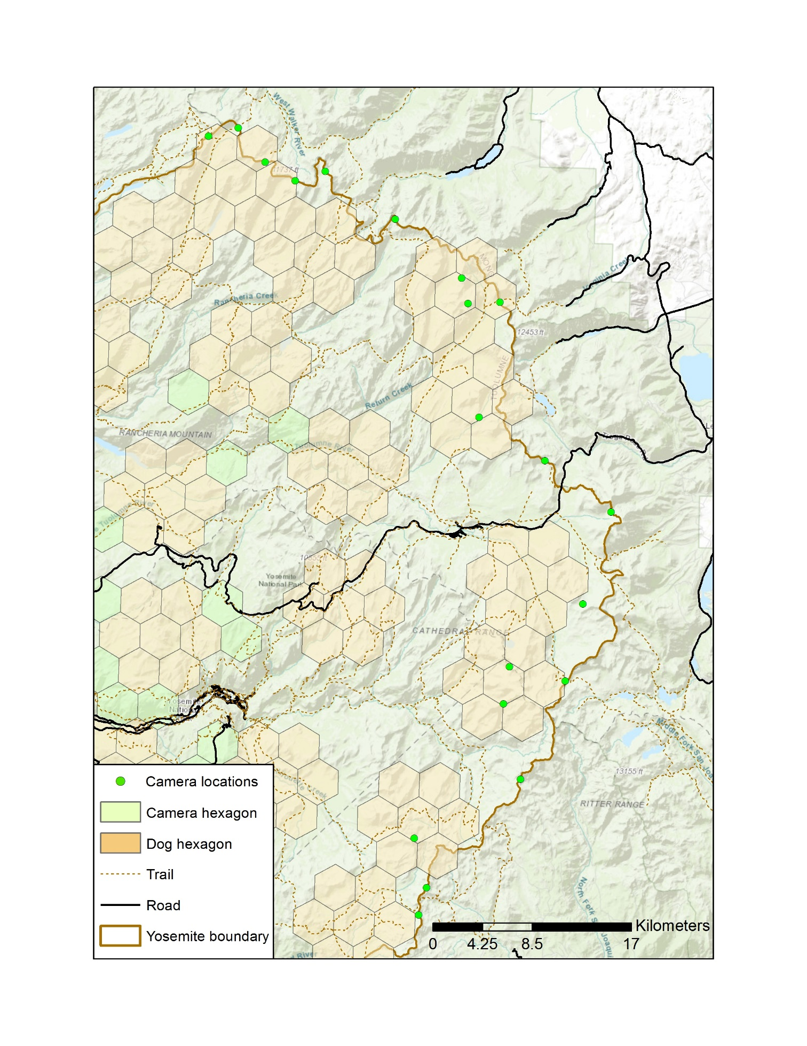

Figure 3. Proposed locations for 20 remotely-triggered cameras at sites of previous detections of Sierra Nevada red fox and areas of predicted high-quality red fox habitat to overwinter in 2019-2020. This map also includes a portion of the detection-dog and mountain-lion camera survey efforts scheduled for 2019 for reference.

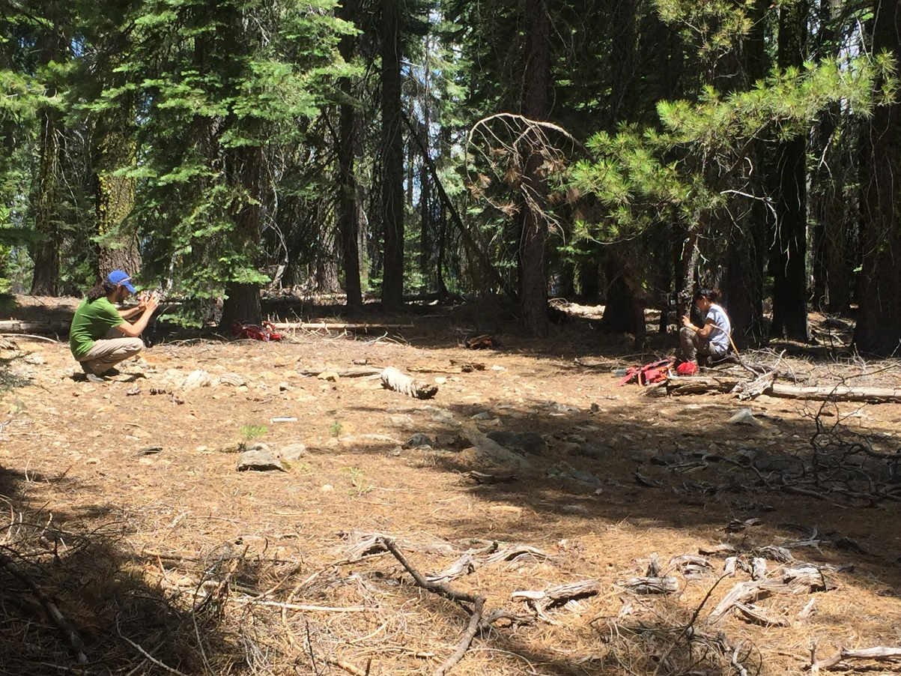

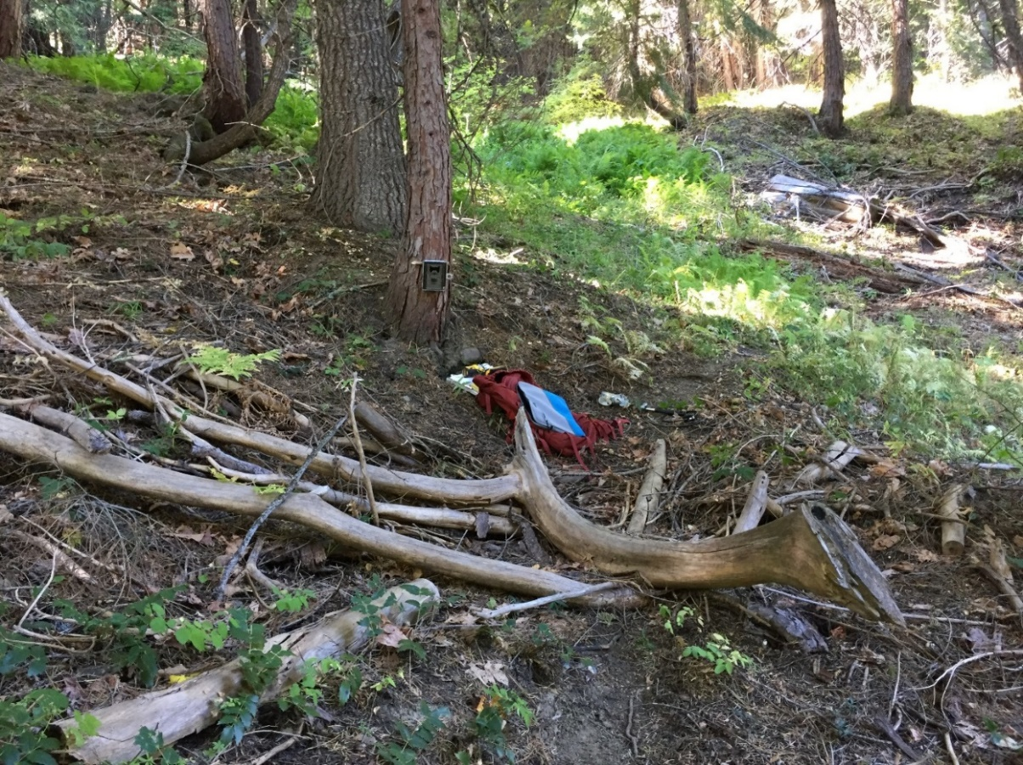

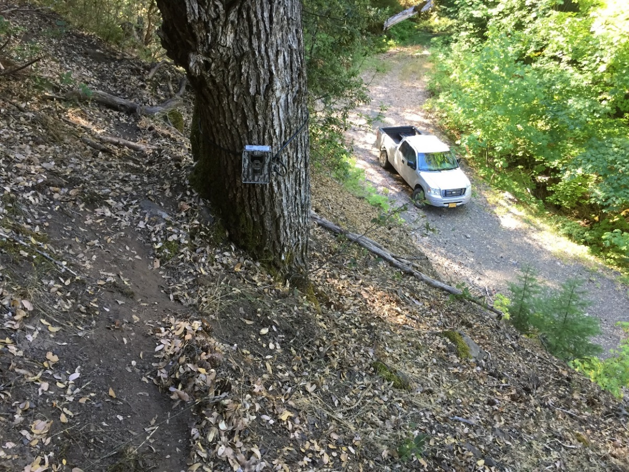

Figure 4. Unbaited, remotely-triggered cameras deployed along a wildlife trail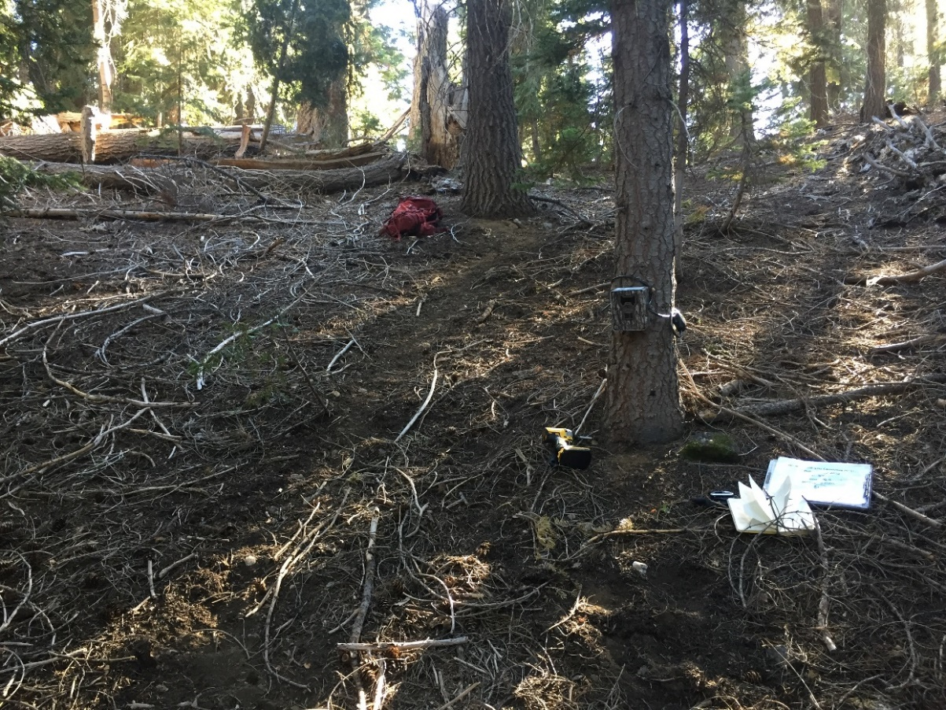. Cameras are typically placed 1 m above the ground for lions, and that it is best if the camera is positioned to take pictures along the length of the wildlife trail, rather than crossing it.

# Appendix 1: Reconyx HC500 camera setup instructions

* To get to the programming mode press the << or >> buttons to cycle through the menu options until you get to Change Setup then press OK.
* Cycle through the next options until you get to Advanced & press OK
* Now you can change the programming to the following:

|  |  |  |  |  |  |  |
| --- | --- | --- | --- | --- | --- | --- |
| Trigger | Time Lapse | Resolution | Night Mode | Date/  time/Temp | CODELOC | User  Label |
| Motion sensor  ON | AM  OFF | 1080P | BALANCED | YEAR | Add | Add |
| Sensitivity **HIGH** | PM  OFF | OK | OK | MONTH | 1436 | CAM_ID  (YNP 04) |
| PICS/Trigger  5 | OK |  |  | DAY | OK | OK |
| Pic Interval  1 second |  |  |  | HOUR |  |  |
| Quite Period  NO |  |  |  | MINUTE |  |  |
| OK |  |  |  | TEMP  °C |  |  |
|  |  |  |  | OK |  |  |

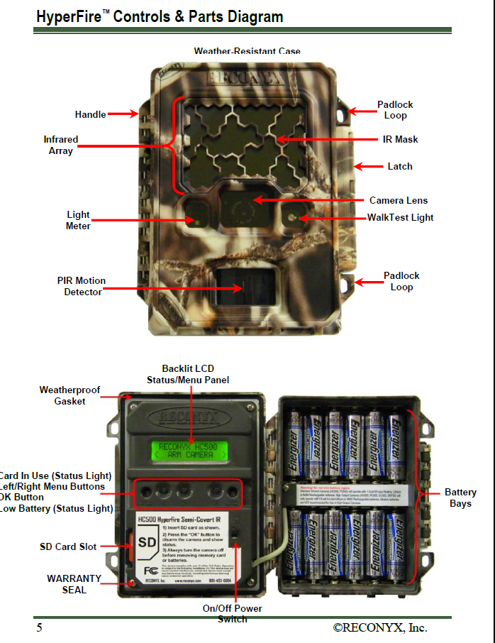

# Appendix 2. Fields for field data collection using Survey123

Field data collected during camera setup:

* Station ID
* Hexagon number
* UTM E, UTM N, Zone, Datum
* SD card ID
* Camera ID
* Date set
* Depart time
* Technicians
* Site description: habitat, slope, aspect, proximity to lake, creek, cliff, etc.
* Camera tree species
* Camera tree dbh (cm)
* Battery type
* Battery %
* Reference photos
* Test photo taken
* Red flashing light observed
* Camera locked
* Lure?

Field data collected during camera checks:

* Date
* Initials
* Battery %
* New SD card ID
* Test photo taken before?
* Test photo taken after?
* Human disturbed?
* Bear disturbed?
* Test photo taken?
* Red flashing light observed?
* Camera locked?
* Lure added?
* Photos uploaded?
* Photos tagged?
* Date removed
* Notes

## Field definitions for datasheet

Camera Deployment Datasheet Fields

Station ID: Station IDs are predefined and unique based on the unique CDFW hexagon ID each camera is in and adding “A” or “B” to make cameras in the same hex unique. Subsequent camera locations would be identified by the CDFW hexagon ID and “C”, “D”, etc. Anytime a camera is moved more than 100 m, it needs a new Station ID and a new datasheet (i.e., need to move camera for some reason at a check due to wind triggers, poor placement at new snow level, etc.). If a camera is moved less than 100 m please make a new datasheet and take new reference photos so the next crew can more easily locate the camera. However, in the database and camera image folder, please identify all photos with the same Station ID. Use your best judgement when cameras are buried and new cameras are set nearby to make up for the buried camera not taking photos. Therefore, when images come in from new camera and the old camera once it’s recovered, photo dates will have to be checked and compared so no check information is lost.

Hexagon number: Unique grid cell ID assigned to a hexagonal cell by CDFW. Use GPS to identify grid cells if uncertain about location.

UTM E: Fill out 6-digit easting coordinate for the camera location. Set GPS to datum NAD83.

UTM N: Fill out 7-digit northing coordinate for the camera location. Set GPS to datum NAD83.

Zone: Fill out UTM Zone. It will usually be zone 11S.

Datum: Use NAD83. Wikipedia definition: “In surveying and geodesy, a datum is a set of reference points on the earth's surface against which position measurements are made, and (often) an associated model of the shape of the earth (reference ellipsoid) to define a geographic coordinate system. Horizontal datums are used for describing a point on the earth's surface, in latitude and longitude or another coordinate system.”

Elev: Fill this field in based on what your GPS unit says for the station.

SD Card ID: Enter ID of SD card left in camera (e.g., WILD-1 or YNP-1A)

Camera ID: Enter ID of camera (e.g., CDFW-1 or YNP-1)

Date set: Enter date in YYYY/MON/DAY format when camera was set up. (2016/DEC/15)

Departure time: Enter time you departed camera location.

Technicians: Enter the 3 letter initials of all technicians involved with camera activity.

Site description: Fill out basic information that could help identify the site, i.e. habitat, near a stream, meadow, pond, etc.

Camera tree species: record tree species

Camera tree dbh (cm): and diameter at breast height (dbh) in centimeters

Battery type: What type of batteries used (eg. Lith).

Battery percentage: What is the battery percentage when camera was set up? Indicate if brand new batteries were put in and if meter seems inaccurate.

Reference Photos: Indicate Y or N for reference photos taken

Test photo taken: Enter Y or N.

Red flashing light obs.: Y or N

Camera locked: Y or N if applicable.

Lure?: Enter Y or N

Camera Checks Datasheet Fields

Date: Date of camera check

Initials: Enter the 3 letter initials of all technicians involved with camera activity

Battery condition: Enter battery life in percent indicated on the camera. A good general rule is to replace when reader says ~<15% (unless battery reader is malfunctioning)

NEW SD Card ID: Enter the ID of the card you left in the camera.

Test photo taken before/after: Indicate yes/no.

Human disturbed: Indicate yes if the camera appears to have moved significantly by a person since the previous visit; otherwise enter no.

Bear disturbed: Indicate yes if the camera appears to have moved significantly by a person since the previous visit; otherwise enter no.

Test photo taken: Enter Y or N.

Red flashing light obs.: Y or N

Camera locked: Y or N if applicable.

Lure added?: Enter Y or N

Photos uploaded: Leave blank until you uploaded them to the computer and the hard drive and then enter Y.

Photos tagged: Leave blank until you can enter Y after tagging them in CPW Access Database.

Date Removed: Enter the date you removed the camera from the field. This should be the same date as the last check.

Notes: Include any information that is relevant for the camera site for the next visit, i.e.- did you notice it could be in an avalanche zone? Is there a tree overhanging nearby that could come down in a big storm, etc.